**WATER TRANSPORT AND FERRYING SYSTEM**

By

[Gitenya Vincent, Wambugu Henry]

[145944, 145696]

Supervisor: Emmanuel Olang

Ap Project Proposal Submitted to the Strathmore School of Computing and Engineering Sciences in partial fulfilment of the requirements for the award of Bachelor of Business Information Technology (BBIT)

**Table of Contents**

**CHAPTER ONE 1**

**1.1 Background 1**

**1.2 Problem Statement 2**

**1.3 General Objectives 3**

**1.4 Specific Objectives 3**

**1.5 Justification 3**

**1.6 Scope 4**

**CHAPTER TWO 5**

**2.1 Introduction 5**

**2.2 Review of the existing water transport system in Kenya 5**

**2.3 Challenges faced in water transport and the gaps present 5**

**2.4: Review of existing systems 6**

**2.4.1 Coastal Shipping for Passengers 6**

**2.4.2 Private Coastal Shipping for Cargo 8**

**2.4.3 Commercial Coastal Shipping for Cargo 9**

**2.5 Gaps 9**

**2.6 Conceptual Framework 10**

**CHAPTER 3 11**

**3.1 Introduction 11**

**3.2 Research Paradigm 11**

**3.3 Methodology 12**

**3.3.1 Ideation and Requirements Engineering 13**

**3.3.2 Analysis and Design 14**

**3.3.3 Development 14**

**3.3.4 Testing 15**

**3.4 Deliverables 15**

**Appendix 1 15**

**Abstract 15**

**LIST OF FIGURES**

**Figure 1Representation of Network protocols utilized by a marine vessel and their interactions with other adjacent vessels or coastal services** 7

**Figure 2: Conceptual framework Diagram** 10

**Figure 3: An example of OOAD paradigm** 12

**Figure 4An Example of Scrum Methodology** 13

**Figure 5: A Gantt Chart representing the process schedule** 15

**CHAPTER ON****E**

## **1.1 Background**

“When one thinks water transport, they only see a novel concept, move one item from point A to point B over a body of water for example a lake or ocean. But that would be merely scratching the surface. Since time immemorial, water transport has served as the backbone of various communities and empires, undergoing very many significant steps in its evolution process to what it is today. Water transport is a never-ending constant for as long as there exists a body of water and vessels that are in a position to navigate them. But in recent times we have experienced an increase in instances of organizations suffering losses due to losing or damaging of cargo during transportation from one place to another using water transport. Another issue is the loss of life due to overloading of vessels used in water transport.” (Association, 2022)

“There are different ways in which manufacturers and suppliers can suffer from cargo damage during transit. First, damaged items are typically returned for replacement or full refund which not only incurs additional costs but can have a negative impact on both the carrier’s and the seller’s reputation. Second, the components, parts, and equipment that are damaged often result in wasted time. This is why, carriers need to ensure that tools, equipment, and other cargo are protected from damage, taking into account factors such as handling, humidity, temperature, contamination, vibration, impact, and static charges.”(International Forwarding Association, 2022)

“In the last few years there has been a steady rise in instances of injuries occurring in water transport due to a variety of reasons and in some instances death.” (Health, 2)

“For people between the ages of five and forty-four years, injuries are one of the top three causes of death worldwide, killing 4.5 million people globally in 2017.” (Bollyky, Injuries, Drowning and Boat Safety in Sub-Saharan Africa, 2019) “Even when injuries do not result in death, they can inflict serious disability and lifelong misery on survivors and impose heavy costs on health care systems, families, and individuals. The economic, social, and health consequences are disproportionately borne by the low-income countries that can least afford them. Deaths from injuries have been declining in every region except in sub-Saharan Africa, where they have been increasing as share of the deaths in the region since 2010.” (Bollyky, Injuries, Drowning and Boat Safety in Sub-Saharan Africa, 2019)

“Based on this research, there appears to be a steady decrease in guaranteed safety of both goods and passengers in the sector of water transport. In spite of the strides made to enhance safety, there seems to be a number of unresolved issues that are starting to rear their collective ugly heads and if not dealt with can lead to further damages with very dire consequences.” (Femi Ola Aiyegbajeje, 2023)

“Importers, manufacturers, shippers, and freight forwarders should take measures to minimize the risk of damage and associated operational and financial losses. To restrict movement and protect cargo, it is important to use the proper dunnage material and lashings. Also, frozen cargo should be inspected for flavor and color changes, black spots, odor, fluid migration, desiccation, and dehydration.” (Arviem, 2020)

“Carriers need to ensure proper temperature controls and a valid inspection certificate when shipping reefer containers. The distribution of weight and stowage of cargo in containers should be well planned. Lastly, when transporting goods that are susceptible to water damage, it is important that carriers choose the correct route and seal all doors of the containers.”(International Forwarding Association, 2022)

“All in all, the safety of cargo as well as passengers is very paramount not only for individuals and businesses but for the sake of international relations and safety of marine life as well. Our system looks to close gaps and ensure that vessels transport cargo as well

as passengers safely by ensuring overloading does not take place.” (Manjur Khan, 2023)

## **1.2 Problem Statement**

“In recent times there has been a rapid increase in the frequency of accidents as well as businesses realizing losses due to the use of water transport. The various factors contributing to this include overloading of passengers on ferries, transportation companies packaging cargo to the wrong locations, cargo being misplaced or in some instances lost in transit.” (IMO/ILO/UNECE, 2014)

“As a result of the ship sitting on water for a long period of time the cargo is unlikely to be checked for the period of time it is in these adverse and potentially humid conditions. As such, this can lead to the movement of cargo within a container, potential water leakage and even bad odours if the goods are not packaged correctly, which ultimately leads to damage.” (Barrington Freight, 2018)

“These are problems are encountered in the sense that cargo that is unaccounted cargo can lead to organizations realizing losses and passengers becoming injured or perishing which will expose the transporters to the risk of facing lawsuits and in most if not all instances paying some form of compensation to the affected parties. The gap in this sector is that most companies will lose credibility and authenticity because of losing or misplacing of cargo or overloading passengers.” (Mutual, 2008)

“The greater the weight it is supporting, the lower the vessel sits in the water and the more likely it is that water will come over the side or into the hull. Once there is water ingress, the vessel is likely to become unstable and can be easily swamped or capsized.” (Maritime Safety Victoria, 2017)

## **1.3 General Objectives**

The aim of the project is to create a water transport system to enable organizations to track their cargo during transportation and track the number of people using the ferry per day.

## **1.4 Specific Objectives**

1. To review the existing water transport system in Kenya.
2. To establish challenges faced in water transport and identify the gaps present.
3. To design a system to solve the challenges faced in water transport and develop a system that will be used by passengers and organizations to transport their cargo and to monitor it in transit.
4. To test the proposed system.

**Research Questions**

1. What is the current system used to manage water transport?
2. What are the challenges faced in water transport?
3. What designs and development methods are best for the system?
4. What is the best way to test the system?

## **Justification**

“The reason for the project is to increase the favorability of people using water transport and providing an opportunity to all types of organizations to access ferry services. The goal is to make people feel that water transport can be easily accessible as inland transport and is also reliable especially with the factor of overpopulation being a major demerit of inland transport. The benefit of this system is that passengers will be able to book their trip depending on the availability of ferries, they will be able to be updated on the progress of their journey if there were those who would want to alight on the next stop, they will also be able to log in and cancel their trips incase of any mistakes they would have done. For organizations, they will be able to log in, book a spot on the ferry for their cargo and be able to monitor it during transit.” (Transport, 2023)

“The difference that is being viewed to bring to the current water transport system has made people lose confidence in using it, they would prefer using inland transport and incur the high costs in long distance transportation. For passengers this will many affect the less privileged members of society where they may need to go somewhere but due to the lack of proper capital the ought to forfeit and for organizations their only option is cut off their vision of expanding to a global level and withholding their products to the area they are located. Our systems intend to provide a bridge to all to access ferry services that will be at fair prices and enable its users to express their satisfaction with their trip, which will be a light to win back the confidence of in water transport.” (Committee, 2003)

## **Scope**

The proposed study focuses on creating a web-based system that will be accessed with at least 4GB internet access speeds and will allow a user to choose what services they want to access between passenger and cargo from the system. On the passenger side, they can book their trip on the ferry, choose a stop they would like to alight from the listed options, they will be able to see the location they had chosen to as their stop and they will also be able to delete their booked trip if by any chance they had a change of plans. The cargo side will have almost the same features as the passenger side, but its payment rates will be determined by the weight of the cargo and there will be prompt sent to the cargo owners based on the estimated time taken to get from one point to another. This system will attempt to simulate payment processes that will be used by organizations and individuals in Kenya, however, the system will only be deal with passengers without vehicles when booking.

**Limitations**

As this project will be embarked on, limitations such as weather conditions, internet speeds required to access the system, time taken to load cargo onto the ferry will be encountered.

**Delimitations**

Interventions that will be employed to tackle these limitations will include setting up a function that will enable the user to retain their progress in booking in case of internet downtime to ensure a smooth time operating the system in place of unstable internet. Cargo loading will be set to start some time before the allocated departure time of the ferry to avoid delay. For the weather conditions there will be an alert to the users that a delay will be experienced.

# **CHAPTER TWO**

# **2.1 Introduction**

This chapter reviews the existing water transport systems that have been used as well as the systems that are currently in use. It also highlights the challenges that water transport faces and the gaps present. This chapter reviews existing systems highlighting what measures were undertaken as well as the gaps that were observed and acknowledged. It also provides a conceptual framework which reflects the desired outcome of the planned system.

# **2.2 Review of the existing water transport system in Kenya**

“In Kenya, water transport assumes a critical part in associating various districts and working with the development of individuals, merchandise, and administrations. The nation brags a different organization water transport framework, going from streams and lakes to seaside waters. The largest freshwater lake in Africa, Lake Victoria, connects Kenya to its neighbors and is a crucial hub for inland water transportation. Additionally, important transportation routes are provided by major rivers like the Tana and Athi. The Indian Ocean provides opportunities for maritime transportation and trade along its coastline. In spite of confronting difficulties, for example, lacking framework and restricted assets, Kenya's water transport frameworks contribute essentially to the nation's economy and proposition important options in contrast to street and air transport. This review will examine Kenya's current water transportation systems, looking at their advantages, disadvantages, and opportunities for improvement.” (Kelleher, 2019)

“Mombasa has the only commercial port that reaches international standards. Mombasa's commercial port is called Kilindini Harbour and is run by the Kenya Ports Authority, it lies on the Indian Ocean. There are plans to build another international port in Lamu to the north east of Mombasa. There is an inland port at Kisumu which serves Lake Victoria. In 2015 a new ferry was delivered to Kisumu by road.” (Wikipedia)

# **2.3 Challenges faced in water transport and the gaps present**

“Water transport assumes an imperative part in worldwide exchange and transportation, working with the development of merchandise and individuals across huge distances. However, this essential mode of transportation is constrained in both its effectiveness and sustainability by a number of obstacles and gaps. Inadequate port infrastructure, which restricts handling capacity and causes congestion issues, is one of the major obstacles. Furthermore, the absence of normalized methodology and guidelines among various nations presents troubles for smooth tasks and coordination. Additionally, environmental issues like pollution and the effects of climate change on sea levels and navigation routes exacerbate the difficulties associated with water transportation. To get the most out of the potential of water transport as a sustainable and effective method of global transportation, it is essential to close these gaps and address these issues**.”** (Nations, 2023)

The challenges faced in water transport vary but these are the main reasons:

“1. Slow:

Speed of Inland water transport is very slow and therefore this mode of transport is unsuitable where time is an important factor.

2. Limited Area of Operation:

It can be used only in a limited area which is served by deep canals and rivers.

3. Seasonal Character**:**

Rivers and canals cannot be operated for transportation throughout the year as water may freeze during winter or water level may go very much down during summer.

4. Unreliable:

The inland water transport by rivers is unreliable. Sometimes the river changes its course which causes dislocation in the normal route of the trade.

5. Unsuitable for Small Business**:**

Inland water transport by rivers and canals is not suitable for small traders, as it takes normally a longer time to carry goods from one place to another through this form of transport.” (Agarwal)

# **2.4: Review of existing systems**

# **2.4.1 Coastal Shipping for Passengers**

“Coastal shipping for passengers or more commonly known as Passenger domestic transport is the transport of people and their belongings along the coasts and waterways of a country or region. It provides alternatives to traditional land transportation such as road, rail and air transportation. Domestic shipping allows passengers to enjoy scenic routes, experience sea adventures and explore coastal destinations while benefiting from the convenience of organized transportation. In this type of trip, purpose-built passenger vessels such as ferries, cruise ships and catamarans travel along the coast and dock at various ports and terminals to pick up and drop off passengers. Passenger Coastal Navigation operates on established routes and offers a wide range of services from short commuter trips to long voyages, offering a unique and leisurely way to explore coastal areas, islands and seaside towns. An instance of a step taken to improve this mode of transportation is the planned implementation and use of a water bus.” (Arviem, 2020)

“Kenyan firm Globology Ltd has scaled-up the provision of waterbus passenger transport services on Lake Victoria with the launch of a water bus vessel to help reduce maritime accidents and ensure affordable transportation.

The vessel is part of the five new ferries that are being built by the firm for passenger and goods transportation across Kenya, Tanzania and Uganda, with the support of Sh444 million from UK government. The three East Africa nations share Lake Victoria’s waters where transportation has mainly relied on old ferries and boats or canoes.” (Otieno, 2022)

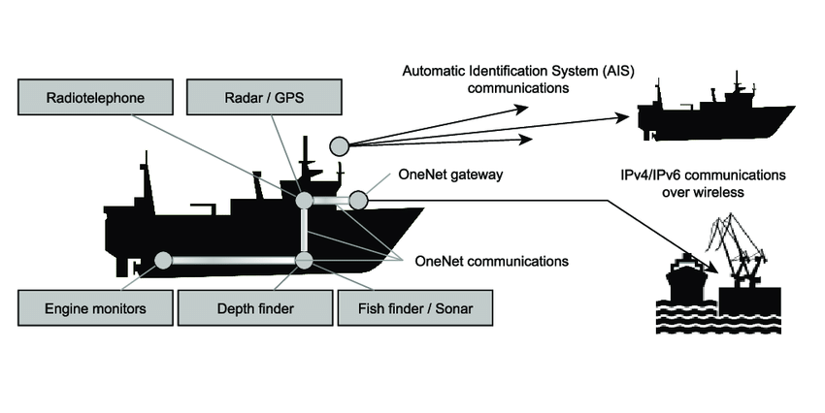

**Figure 1Representation of Network protocols utilized by a marine vessel and their interactions with other adjacent vessels or coastal services**

(Tran, 2021)

# **2.4.2 Private Coastal Shipping for Cargo**

“Private Coastal shipping for cargo refers to the transportation of cargo that is transported by water along a nation's or region's coasts is referred to as coastal shipping. It entails the transportation of cargo between ports and harbors that are close to one another, sometimes within the same nation or area. In especially for big or bulky commodities that would be impossible to move over long distances by road or rail, coastal shipping offers an effective and affordable alternative to land-based transportation. This kind of transportation relies on specialized ships, sometimes referred to as coastal or short-sea ships, which are built to travel through coastal waters and may accommodate a variety of goods and these services are offered by private firms that offer rates that are deemed to be more affordable when compared to the rates offered by the government. Coastal shipping is essential for promoting domestic trade, tying coastal towns together, and easing traffic congestion. There are many instances of attempts made by organizations to enhance this form of transport.” (IMO/ILO/UNECE, 2014)

“A Mombasa-based shipping company has launched a transport service along the Kenyan coastline opening the door to faster transit times and lower freight charges. Lamu Shipping Limited also plans to provide an economical cargo and passenger maritime transport between Kenyan ports According to the firm, the cost of transportation of goods to Lamu will be lowered by nearly 25 per cent. The shipping company is expected to bring competition in the sector as it ferries cargo between Mombasa, Lamu and other small ports along the Kenyan coastline. The first vessel M.V Amu 1 arrived in Mombasa a month ago from Malaysia and is set to start a weekly service to Lamu.

“This venture will open doors for maritime costal trade in Kenya and create job opportunities for our seafarers and other cadres of workers,” said Capt Twalib Khamis, the Chief Executive Officer.” (Atieno, 2019)

“Lamu Shipping has built up a professional Shipping to provide Port Agency Services | Kenya and for supporting vessels being represented by our agency. It is our definite goal to uphold the high standards of this industry. Therefore, we support various vessels calling on the port for their operations or other activities which results in ship owners to willingly contact us and put us in charge of their vessels’ operations and daily needs.

At Lamu Shipping we strongly believe we are in business to help your business thrive, even in challenging times. Our promise to provide the best in shipping, logistics and marine services is one we take seriously. Lamu Shipping (LSL) is a Shipping Agency and Ship management company based in Mombasa, Kenya with an objective to provide Port Agency Services and aspire to be a regional leader in Coastal Shipping and Ship agency.Lamu Shipping is a global leader in ship and hub agency services, representing more than 1,000 customers.” (Lamu Shipping Limited, n.d.)

# **2.4.3 Commercial Coastal Shipping for Cargo**

“Commercial Coastal Shipping for Cargo or simply known as Cargo transport. The movement of products and commodities along a country's or region's coasts by water is known as commercial coastal shipping for cargo. It entails the transportation of cargo between different ports and harbors situated along a particular coastline using specialized vessels created for effective maritime transportation. This mode of shipping plays a vital role in facilitating trade and commerce, offering a cost-effective and environmentally friendly alternative to other modes of transport like road or air. Commercial coastal shipping utilizes well-established shipping lanes and is supported by a network of ports, terminals, and logistical infrastructure. This shipping method offers a dependable and effective way to move substantial amounts of cargo by taking advantage of the extensive coastline. This form of cargo transportation is primarily offered by the government who provide the locomotives used to transport the mentioned cargo and charge according to the weight of the cargo being transported. There are organizations such as the Kenya Maritime Authority which have been started with this in mind.” (Menon, 2022)

# **2.5 Gaps**

“Water transport assumes an imperative part in worldwide exchange and transportation, working with the development of merchandise and individuals across huge distances. However, this essential mode of transportation is constrained in both its effectiveness and sustainability by a number of obstacles and gaps. Inadequate port infrastructure, which restricts handling capacity and causes congestion issues, is one of the major obstacles. Furthermore, the absence of normalized methodology and guidelines among various nations presents troubles for smooth tasks and coordination. Additionally, environmental issues like pollution and the effects of climate change on sea levels and navigation routes exacerbate the difficulties associated with water transportation. To get the most out of the potential of water transport as a sustainable and effective method of global transportation, it is essential to close these gaps and address these issues.” (Nations, 2023)

“Environmental issues in Kenya include deforestation, soil erosion, desertification, water shortage and degraded water quality, flooding, poaching, and domestic and industrial pollution.” (Wikipedia)

# **2.6 Conceptual Framework**

“The conceptual architecture for the water transportation system includes a thorough infrastructure created to move people and commodities across water bodies in an effective manner. The system is made up of a number of interrelated parts, such as ports, ships, nautical paths, and auxiliary buildings. The framework's main focus is on the seamless integration of freight and passenger transportation with the goals of maximizing resource use, minimizing environmental effect, and ensuring safe and dependable travel. Specialized boats with loading and unloading systems are used to convey cargo more easily, enabling effective handling and storage of commodities. In order to give a pleasant travel experience, passenger ships with luxurious facilities and safety elements are added. Additionally, the framework makes use of cutting-edge navigational technology like GPS and radar systems to enable exact route planning and monitoring, improving overall.” (Arviem, 2020)

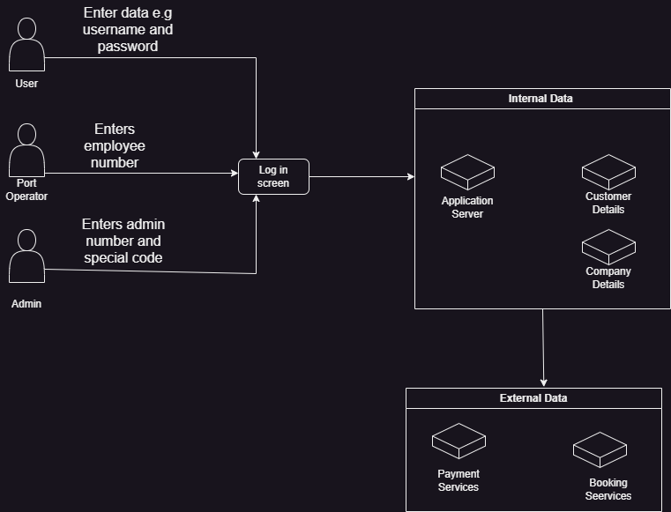

**Figure 2: Conceptual framework Diagram**

# **CHAPTER 3**

# **3.1 Introduction**

“This chapter sets out to explain further the methodology selected to give an idea of the structure the system will be built under. It also describes the plans put in place to show how the system works, how it will be designed and the major stakeholders involved.” (Mutual, 2008)

# **3.2 Research Paradigm**

“The research paradigm selected to be used in this project is Object Oriented Analysis and Design. The reason behind this is because the usage of Object-Oriented Analysis and Design (OOAD), a potent paradigm for creating intricate software systems, is supported by a number of crucial elements. OOAD prioritizes a structured and modular approach to system development. The system may be made simpler to comprehend, maintain, and adapt over time by disassembling it into smaller, self-contained units. Furthermore, OOAD promotes code reuse through the idea of inheritance, enabling developers to build on already-existing objects and classes and reducing time and effort spent on development. Additionally, OOAD encourages encapsulation, which improves data security and abstraction by keeping an object's internal details secret and only granting other objects access to pertinent information. This increases system dependability generally and lessens the possibility of unwanted adverse effects” (Committee, 2003)

Object-Oriented Analysis (OOA):

Focus on objects: OOA focuses on the objects involved in a software system, modeling them as instances of classes that encapsulate both data and behavior.

Bottom-up approach: OOA follows a bottom-up approach, building complex systems from smaller, simpler objects that can be more easily understood.

Object-centered: OOA focuses on the objects that make up a software system, modeling their relationships and interactions.

Emphasis on object-oriented design patterns: OOA emphasizes the reuse of objects and object-oriented design patterns, reducing the amount of code that needs to be written and improving the quality and consistency of the software.” (Ammad, n.d.)

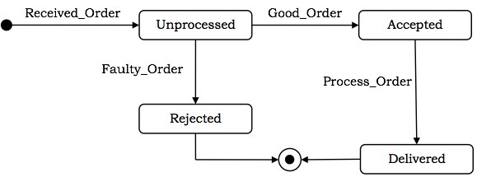

**Figure 3: An example of OOAD paradigm**

(tutorialspoint, n.d.)

# **3.3 Methodology**

The methodology selected to be used for this project is the Adaptive (Agile) methodology. The specific methodology under agile to be used is scrum. The reason according to research being:

“With Scrum work is done by the development team simultaneously rather than sequentially. Programmers code “on the fly” and do not wait until all questions are answered and everything is crystal clear before they start to program. Everything is flexible and changeable during the life of the project and even after. The same is true of testing code which is constantly done and not just at the end after all coding has been completed.

With Scrum there is adaptability. Changes can be supported and integrated into a project currently in progress. Under Scrum the scope of the project (what is to be done) is variable but time and cost are constant. This is a major difference with the traditional approach where the scope is constant (no changes allowed, or if they are, reluctantly) but time and cost are variable.

With Scrum, tasks are prioritized by order of importance and this usually means that tasks to be completed first will probably affect return on investment the most. By releasing “done” chunks of prioritized work in a sprint, portions of your product are on the market faster than in traditional projects where completed work is released in total at the end of the project.

With Scrum the development team is key. The members, usually five to nine people, interface closely and have the motto “all for one and one for all”. Their main goal in a given sprint is to complete as soon as possible useable segments of prioritized work that will have business value. Helping out where needed doing any job, the team as a whole is responsible for what is required. In Scrum pair programming is encouraged; the idea being two heads are better than one. This results in faster coding completion time with better quality.

Because a Scrum team does not have a boss to tell them what to do and when they identify more with the project as their own. This helps boost their morale. They also have a ScrumMaster, who mentors and protects them from outside negative pressure. Also because of techniques like pair programming, their rate of increased knowledge is greater than it would be if they coded alone. For all of these reasons morale and job satisfaction is higher.

With projects run using the Agile/Scrum approach, there also is greater customer/user satisfaction. A key reason for this is that the users are getting useable portions of completed product quicker. They can then try out what they received and report back their findings. This is a critical factor in the overall success of the project. Certain previously submitted requests may no longer be required in which case unnecessary work will be saved and the overall project can be brought in sooner than originally scheduled. Or, the user may find changes are needed to his or her original request for work to be done. If this occurs there should be no problem as Scrum is designed for adaptability and to incorporate change expeditiously.” (AGILEST, n.d.)

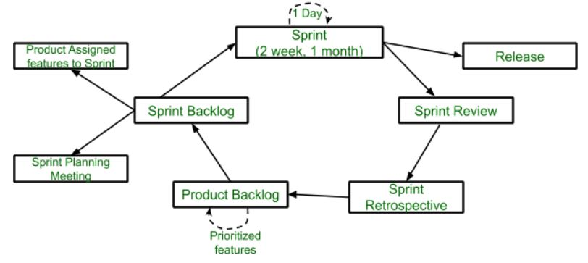

**Figure 4An Example of Scrum Methodology**

(SakshiBhakhra, n.d.)

# **3.3.1 Ideation and Requirements Engineering**

“The problems which were unearthed were the loss of cargo and failure to track the number of passengers using water transport was found to be affecting the companies in the sense that they were making losses and losing clients as well as being forced to pay compensation due to the loss of lives experienced while transporting passengers. Data to be collected will be reviews from passengers critiquing the use of water transport, the positive as well as negative impacts of using said transport as well as reviews from organizations which have experienced loss of cargo due to water transport.” (Manjur Khan, 2023)

The functional and non-functional requirements will be gathered by using the following methods: gathering and analysis of data, identification of stakeholders, interviews among other methods.

# **3.3.2 Analysis and Design**

“The Object-Oriented Programming Analysis Design (OOAD) was agreed on as the best research approach to use for this project. The reason behind this selection is because it allows the developers to break down the system into various parts and ensure that resources are utilized and there is no wastage of resources. The diagrams to be used are Use case diagrams, Class diagrams, Sequence diagrams, ERD diagrams, Database schemas and GUI designs of forms and reports as well as Wireframes. Reason being these diagrams give a clear and accurate representation and illustration of the processes undertaken in the system and where data is stored. The tools to be used include computers and mobile phones. Reason being they contain applications that can be used to develop the system.” (Arviem, 2020)

# **3.3.3 Development**

The system to be built for this project will be a web system. Reason being a web system allows organizations to track their cargo using GPS comfortably and it allows for tickets to be issued to passengers and for payments to be made and for customer data to be retained for future trips. The tools to be used will be front end, back end as well as databases. Reasons being the databases will be used to store customer data when they book a ticket as well as organization data pertaining the cargo they intend to transport and the weight of cargo, front end to provide a platform for users and organizations to access the application, either book a ticket or transport cargo and simulate payment and back end to ensure that the limits of access for customers, organizations and administrators are well defined. The programming languages chosen to realize these objectives are Java, HTML and CSS. Reason being these languages use a syntax that is almost similar to the English Language hence the codes are easy to understand. The environments to be used are IntelliJ, Microsoft Visual Code and phpMyAdmin. Reason being they use high level languages as their syntax.

# **3.3.4 Testing**

“The main method to be used to confirm that the system is fit for use is by conducting various tests such as allowing users to use the system to carry out bookings and make payments. These tests will be carried out to observe what happens what happens to the system when a device without internet tries to access it, when a part of the system is tampered with and what happens when the system crashes and any other errors or gaps that may be encountered during the development and use of the system.” (Nations, 2023)

# **3.4 Deliverables**

“The project will be represented theoretically using class diagrams, use case diagrams, sequence diagrams, ERDs, database schemas as well as GUI designs of forms and reports. The documents will include User Manuals for those interacting with the system for the first time, reports documenting how the system was developed, errors encountered, how the idea of the system was born and how it will function and the purpose it will serve. The users will be members of the public as well as organizations which want to transport cargo. In terms of the system while users will not have complete access to the system. Working output to be expected is a receipt confirming that a ticket has been booked or an organization has paid to ferry cargo of a certain weight.” (creately, 2022)

# **Appendix 1**

|  |  |  |  |  |  |  |  |  |  |  |  |  |
| --- | --- | --- | --- | --- | --- | --- | --- | --- | --- | --- | --- | --- |
| Activity | Week 1 | Week 2 | Week 3 | Week 4 | Week 5 | Week 6 | Week 7 | Week 8 | Week 9 | Week 10 | Week 11 | Week 12 |
| Concept Note |  |  |  |  |  |  |  |  |  |  |  |  |
| Proposal Writing |  |  |  |  |  |  |  |  |  |  |  |  |
| System Design |  |  |  |  |  |  |  |  |  |  |  |  |
| System Development |  |  |  |  |  |  |  |  |  |  |  |  |
| Conclusion |  |  |  |  |  |  |  |  |  |  |  |  |

**Figure 5: A Gantt Chart representing the process schedule**

# **Abstract**

When transportation by water is discussed, the simple definition is moving from point A to point B over a body of water. Water transportation, however, has served as the backbone of countless communities and empires, developing through a number of crucial stages to reach its current state. Maritime transport will always exist as long as there are bodies of water and ships that can sail them. But in recent years, there have been increasing instances of firms suffering financial losses as a result of goods being misplaced or harmed while being transported by sea. This proposal provides an overview of the past and present water transportation methods that have been employed. It also emphasizes the difficulties and gaps that are prevalent in water transportation. This proposal evaluates the current systems, emphasizing the actions made as well as the deficiencies that were noticed and acknowledged and offers a conceptual framework that represents the desired end result of the proposed system. In order to provide users with a better understanding of the framework around which the system will be created, this explains the process in more detail. The plans implemented to demonstrate the system's functionality, design, and key stakeholders are also described.